RTU Condenser Fouling

Table 7. Test Conditions for RTU Condenser Fouling Fault

|  |  |
| --- | --- |
| Fault Intensity Variable: | Percent reduction in condenser coil air flow at full load |
| Method of Fault Imposition: | Cover the condenser face using screen, mesh, or cloth |
| Fault Test Intensities: | Baseline  25% air flow reduction  50% air flow reduction |
| Weather Test Conditions: | Warm |

RTU-VAV System Operation Condition

As described in the test plan, for consistency, the RTU was running at full load (i.e., supply fan was running always 100% with all VAV dampers fully open). The RTU discharge temperature was set to 55F during the test[1].

Baseline Test

**Day of the test:** September 1st, 2017 (midnight to midnight)

**Average daily ambient temperature:** 70.6F

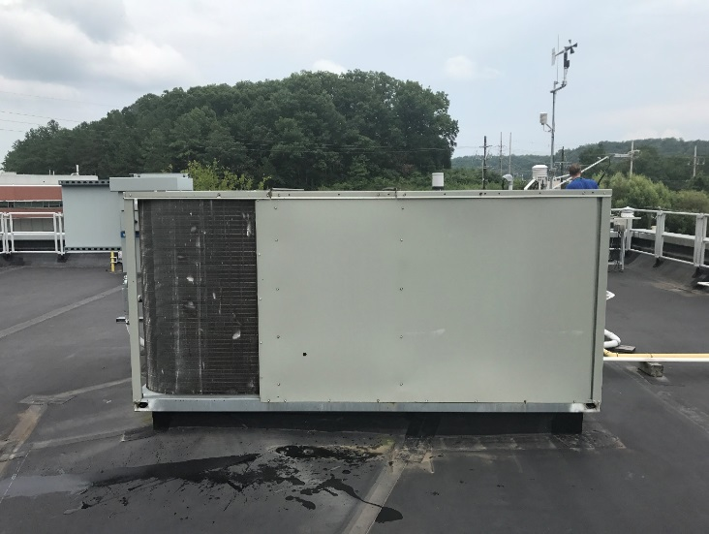Baseline test was performed after 25% and 50% air flow reduction tests due to some schedule conflict. The average daily ambient temperature during the test was 70.6F with minimum and maximum temperature were 61.9F and 76.5F, respectively. As the weather condition for the baseline test was not warm enough (i.e., lower than daily average of 75F), the baseline test may need to be redone next summer.

Per the test plan, the occupancy hours should be set to 7 am to 10 pm, whereas the actual operation for occupied hours was 6:38am to 9 38pm due to off-clock issue at Johnson control. The time was manually corrected after the baseline test, but the 25% and 50% air flow reduction tests have the same issue in occupied hours as these tests were performed before the baseline test.

**Figure 1: Baseline RTU test**

25% air flow reduction

**Day of the test:** August 27th, 2017 (midnight to midnight)

**Average daily ambient temperature:** 73.3F

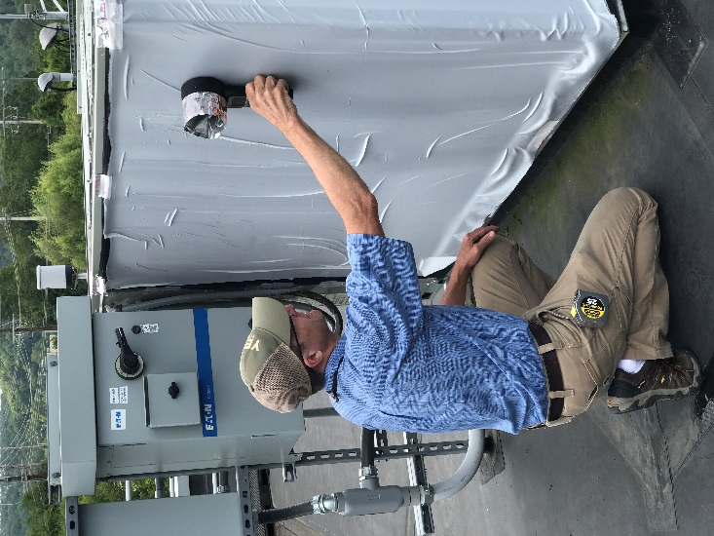25% air flow reduction test was performed. As described in the test plan, air flows with and without fabric that covers the condenser were measured using a hand-held anemometer to verify the air flow reduction (Figure 2). The installed fabric for 25% air flow reduction test reduces the air flow about 28%. After applying the blocking media, it was remained in 2 full days, and the last day of data was used for the test results.

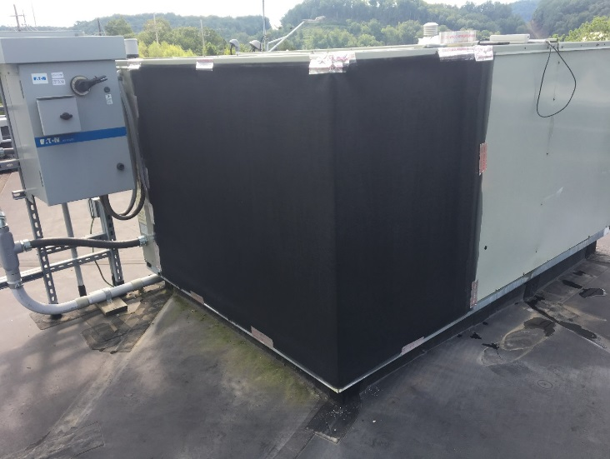The average daily ambient temperature during the test was 73.3F with minimum and maximum temperature were 62.5F and 87.8F, respectively. Although the weather condition for the test was not warm enough (i.e., lower than daily average of 75F), the maximum air temperature reached 88F during the test, which can be observed in typical cooling season at the site.

**Figure 2: Air Flow Measurement**

**Figure 3: 25% Air Flow Reduction Test**

50% air flow reduction

**Day of the test:** August 29th, 2017 (midnight to midnight)

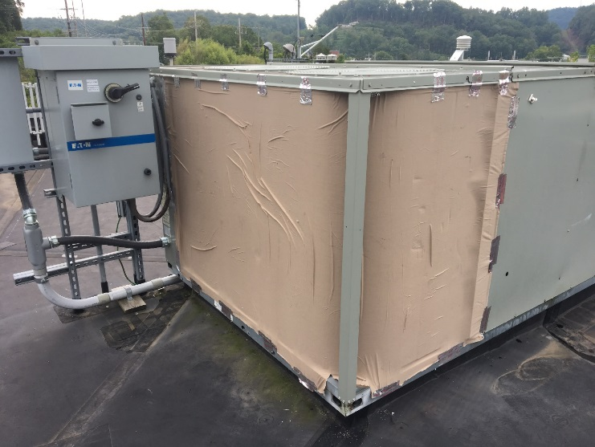**Average daily ambient temperature:** 71.70F

50% air flow reduction test was performed. As described in the test plan, air flows with and without fabric that covers the condenser were measured using a hand-held anemometer to verify the air flow reduction. The installed fabric for 50% air flow reduction test reduces the air flow about 58%. After applying the blocking media, it was remained in 2 full days, and the last day of data was used for the test results.

The average daily ambient temperature during the test was 71.7F with minimum and maximum temperature were 61.2F and 84.0F, respectively. Although the weather condition for the test was not warm enough (i.e., lower than daily average of 75F), the maximum air temperature reached 84F during the test, which can be observed in typical cooling season at the site.

**Figure 4: 50% Air Flow Reduction Test**

1. With this operation condition, the rooms can be overcooled due to excessive air flow to each zone. Therefore, the VAV reheating coil was frequently activated to prevent the overcooling, which can be found in the measured data.